- Oracle Autonomous Database
  - Database was created previously working on another school project
  - Connection via Oracle wallet, which was downloaded from Oracle cloud
  - User secrets for secrets to authenticate
- Entities: Tried to use scaffolding, but it had troubles to generate models properly
  - probably for some specific types like XMLTYPES and so on. It succeeded once, when created new database scheme, which had privileges only on non problematic tables
  - We created powershell script to try scaffold each table separately, but it was not successful at first, because all metadata needed to be read first and there was problem with it
  - after successful scaffolding, all names were in Slovak, because database tables are created with Slovak names
  - I used Copilot to generate entities from relational database scheme with a use of FluentAPI to map Slovak names to English ones, so the code should be easy to understand. There was also problem of finding table through EF Core first, because Oracle stores table names uppercase.
  - Downside is manual mapping
- Minimal APIs
  - services
  - mappers
  - iDbContextFactory – useful for Blazor app
- Aaaaaaaaaaaaaaaaaaaaaaaaaaaaaaaaaaaaaaaaaaaaaaaaaaaaaaaaaaaaaaaaaaaaaaaaaaaa -
- Oracle Autonomous Database
  - Database: pre-existing (created for another course project).
  - Connection: via Oracle Wallet (downloaded from Oracle Cloud).
  - Wallet usage:
    - Set TNS_ADMIN to the wallet folder before any Oracle calls (shell or app startup).
    - Do NOT commit the wallet directory; add it to .gitignore.
  - Secrets:
    - Use dotnet user-secrets (dev) or environment variables / Azure Key Vault (prod) for credentials.
    - Example runtime setup used in the project: TNS_ADMIN env + connection string from user-secrets or env var.
- Entities / scaffolding
  - Scaffolding attempt:
    - We attempted EF Core reverse engineering (scaffolding) using Oracle.EntityFrameworkCore + Oracle.ManagedDataAccess.Core.
    - Scaffolding failed initially because the EF provider reads schema-wide metadata first and crashed on non-standard column types.
  - Root cause:
    - Oracle-specific types (notably XMLTYPE) and some view/metadata combinations caused the provider to throw (LINQ Single() on metadata).
  - Workarounds applied:
    - Created a limited scaffold DB user (example: li_booker_scaffold) with SELECT only on the non-problematic tables so the provider cannot see the problematic objects.
    - Wrote PowerShell helpers to scaffold safely:
      - scripts/find-failing-table.ps1 — utility used to scaffold accessible tables (or attempt per-table scaffolding).
    - For tables with XMLTYPE (e.g., VYDANIE.VLASTNOSTI_XML) we added manual entity + Fluent API mapping instead of relying on scaffolding.
  - Naming / mapping:
    - Database objects are in Slovak (UPPERCASE). Scaffolding produced classes with DB names.
    - For clarity we converted DB names to English domain model classes and used Fluent API in AppDbContext (or IEntityTypeConfiguration<>) to map English properties to Slovak table/column names.
    - Example files: Model / Model\Configurations\PublicationConfiguration.cs (manual mapping for XMLTYPE).
  - Downsides / notes:
    - Manual mapping required for complex types (XMLTYPE, UDTs, nested types).
    - After successful scaffolding, generated code was adjusted to follow project naming conventions and moved into LiBookerWebApi\Model.
- Minimal API design notes (what we implemented)
  - Services: register AppDbContext + AddDbContextFactory<AppDbContext> for background workers.
  - DI patterns:
    - Inject scoped AppDbContext into request handlers (endpoints).
    - Use IDbContextFactory<AppDbContext> for background/long-lived services (example: SampleBackgroundWorker.cs).
  - Mappers:
    - Keep DTOs and mapping (small mapping layer or System.Text.Json attributes) separate from EF entities.
  - Practical tips:
    - Use .WithName() and .WithTags() on minimal API routes for clear Swagger docs.
    - For read-only endpoints prefer AsNoTracking().
- Security
  - User secrets for development
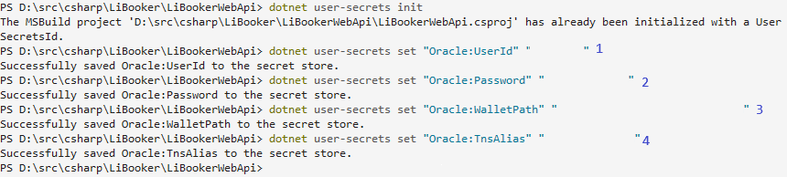
Image 1 - creating user secrets

Publications information (note: indexes on database columns of needed foreign keys are available). These queries are made with pagination.
- Firstly, it took 20 seconds with image loading (BLOB)
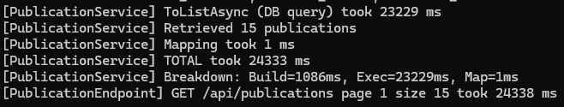
Image 2 – initial GET publications query duration
- 15 seconds without image loading
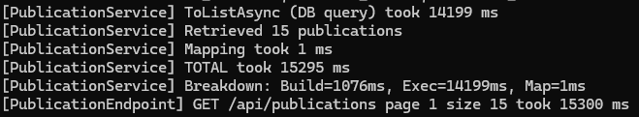
Image 3 – GET publications query duration without image loading
- 10 seconds by enabling pooling (first time 15 seconds also)
  - Build means building of query
  - Exec means database execution of query
  - Map means mapping results to DTOs
  - If we don’t use pooling, then TCP connection is created for every request separately which comes with Oracle wallet authentication
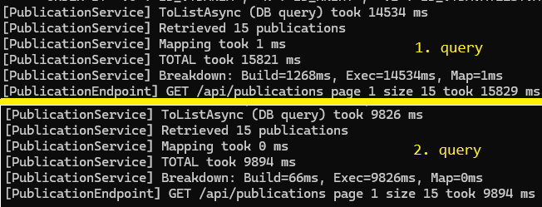
Image 4 - GET publications query duration after enabling database pooling
- Raw SQL for minimal costs
  - Replacing EF Core by raw SQL
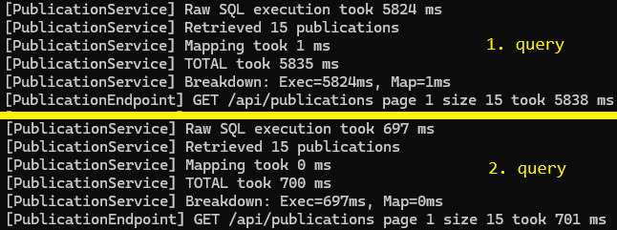
Image 5 – GET publications query after implementation of raw SQL

